YUVA INTERN | WEEK 5 CAPSTONE REPORT
From Data to Decisions: Statistical Inference and Machine Learning for Strategic Recommendations
A comprehensive project report integrating an A/B test of an e-commerce checkout redesign and a machine learning tumour classifier

Executive Summary
This report brings together the analytical work completed during the internship into one end-to-end data science project. Two case studies were carried out with the same disciplined workflow (define the question, prepare data, explore, test or model, validate, interpret): (A) a controlled A/B test of a redesigned checkout page for an online store, analysed with hypothesis tests, and (B) a machine learning classifier that separates malignant from benign tumours. The report then turns the technical results into recommendations that a business or clinical stakeholder can act on.

Headline findings
- The new checkout design works. It converts 16.5% of sessions against 11.6% for the old design (a 42% relative lift, p < 0.001), and customers finish checkout about 4.1 seconds faster. Basket size did not change (p = 0.64), so the gain comes from more buyers, not bigger baskets.
- The gain is worth real money. Revenue per session rose from ₹182 to ₹263, a difference of ₹82 (95% bootstrap interval ₹35 to ₹129). Under the stated assumptions that is roughly ₹8.2 million extra revenue per 100,000 sessions.
- Where the opportunity sits. Mobile users, who are 55% of traffic, convert least (11.2% vs 18.2% on desktop), and first-time customers spend about 17% less per order than returning customers.
- A simple model is enough for the tumour classifier. Logistic regression reached 96.5% test accuracy, 92.9% recall and ROC AUC 0.996, matching or beating a random forest while staying explainable.
- The decision threshold is a policy choice. When a missed cancer is treated as 5 to 10 times worse than a false alarm, a cross-validated threshold of 0.18 cuts missed cancers on the test set from 3 to 1 at the cost of 3 more false alarms.

Top recommendations
# | Recommendation | Why | Priority
1 | Roll out the new checkout to 100% of traffic and track revenue per session, not only conversion | Significant, consistent gain in conversion and revenue, no change in basket size | High
2 | Run a dedicated mobile checkout follow-up test | Mobile is 55% of sessions and has the lowest conversion; subgroup samples are currently too small to judge | High
3 | Launch a first-to-second purchase programme for new customers | Returning and loyal customers spend significantly more per order | Medium
4 | For the classifier, set the threshold from a cost ratio agreed with clinicians and keep a human in the loop | Threshold choice changes missed cancers by about 3x; the model is for decision support only | High
5 | Validate the model on external data before any real-world use | Single small dataset; no external validation yet | High

Important context: the e-commerce data are self-generated (simulated) and the tumour data are a public benchmark. Business impact figures are therefore illustrative and show how the analysis would be used on real data; they are not forecasts for any real company or clinical claims.

1. Introduction

1.1 Background and purpose
Organisations collect large amounts of data, but data only creates value when it changes a decision. A p-value or an accuracy score is not a decision. The aim of this project is to show the complete path from raw data to a recommendation: asking a precise question, choosing a method that fits the data, checking that the method is trustworthy, and translating the result into action with an honest statement of uncertainty.

1.2 Case studies
 | Case study A: E-commerce checkout | Case study B: Tumour classification
Question | Does the redesigned checkout page improve speed, conversion and revenue? | Can measurements of cell nuclei predict whether a tumour is malignant?
Type of problem | Causal comparison (A/B experiment) | Supervised binary classification
Data | 2,400 simulated sessions, 6 variables | 569 patients, 30 features (UCI Wisconsin Diagnostic)
Main methods | Welch t-test, chi-square, one-way ANOVA, Tukey HSD, bootstrap | Logistic regression, KNN, decision tree, random forest, cross-validation, grid search
Stakeholder | Product and growth managers | Clinicians and hospital analytics team

1.3 Report structure
Section 2 describes the shared methodology. Sections 3 and 4 present each case study with supporting visualisations and code. Section 5 synthesises patterns across both studies. Section 6 gives strategic recommendations, Section 7 estimates business impact and research outcomes, and Section 8 discusses limitations and future work. Section 9 concludes. A glossary of statistical terms and the full code appear in the appendices.

2. Methodology
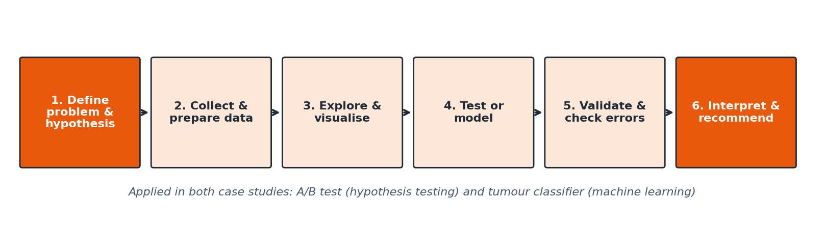
Figure 1: The six-step workflow used in both case studies
The diagram shows the common structure. Reading from left to right: every analysis began with a precisely stated question, moved through data preparation and exploration, applied either a hypothesis test or a predictive model, and ended with validation and an interpretation aimed at a decision maker. The sections below explain the principles applied at each step.
- Hypotheses first. For the A/B test, null and alternative hypotheses and the significance level (α = 0.05) were written before any test was run. Directional hypotheses were used only where the business question was directional.
- Assumptions are checked, not assumed. Normality (Shapiro–Wilk, Q-Q plots), equal variance (Levene) and expected counts were verified; non-parametric alternatives (Mann–Whitney, Kruskal–Wallis) were run as cross-checks.
- Effect sizes and intervals, not just p-values. Cohen's d, Cramér's V, eta-squared and 95% confidence or bootstrap intervals were reported so that statistical significance is not mistaken for practical importance.
- No peeking at the test set. For machine learning, the test set was held out until the final evaluation. Model choice and tuning used stratified 5-fold cross-validation on training data only, and scaling was placed inside a Pipeline to prevent data leakage.
- Metrics that match the cost of errors. Recall, F1 and ROC AUC were used alongside accuracy because the two kinds of error in the classifier have very different consequences.
- Reproducibility. All random seeds are fixed (42) and every analysis is a script that regenerates data, results and figures.
A representative excerpt of the shared approach to validation (from the machine learning case study):
X_tr, X_te, y_tr, y_te = train_test_split(X, y, test_size=0.20, stratify=y, random_state=42)
model = Pipeline([('scale', StandardScaler()),
('clf', LogisticRegression(max_iter=1000, random_state=42))])
cv = StratifiedKFold(n_splits=5, shuffle=True, random_state=42)
scores = cross_validate(model, X_tr, y_tr, cv=cv, scoring=['accuracy','recall','f1','roc_auc'])
Annotation: the stratified split keeps the class mix identical in training and test data; the Pipeline guarantees the scaler only ever sees training folds; cross-validation estimates performance without touching the held-out test set.

3. Case Study A: Evaluating a Checkout Redesign

3.1 Data and exploration
A reproducible dataset of 2,400 sessions was generated, split equally between the Old and New design. Each session records the design shown, device (Mobile 55%, Desktop 35%, Tablet 10%), customer segment (New 45%, Returning 35%, Loyal 20%), checkout time in seconds, whether a purchase occurred and the order value. Order value exists only for purchasers (337 sessions), so analyses of basket size use buyers only.
np.random.seed(42)
design = np.array(['Old']*1200 + ['New']*1200)
device = np.random.choice(['Mobile','Desktop','Tablet'], size=2400, p=[0.55,0.35,0.10])
checkout_time = np.where(design=='Old', np.random.normal(142,28,n), np.random.normal(136,28,n)).clip(30)
converted = (np.random.rand(n) < base + dev_adj).astype(int)
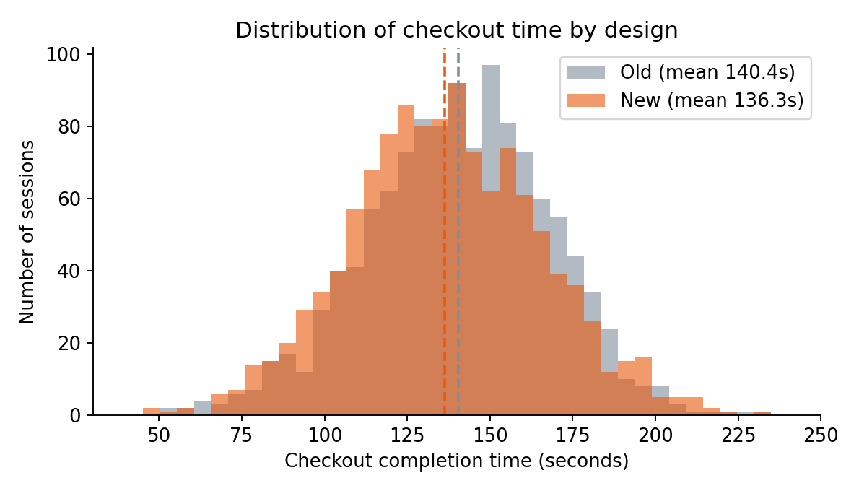
Figure 2: Checkout time by design
How to read this: each bar counts sessions in a time range. The orange (New) distribution sits to the left of the grey (Old) distribution, and the dashed lines mark the means (136.3 s vs 140.4 s). Both are bell-shaped with similar spread, which supports using a t-test.

3.2 Hypothesis tests
Hypothesis | Test | Result | Decision
H1: New design is faster | Welch t-test (one-tailed) | t = -3.57, p < 0.001; difference -4.1 s; 95% CI [-6.4, -1.9]; d = -0.15 | Reject H0
H2: New design converts more | Chi-square / two-proportion z | χ² = 12.02, p < 0.001; 11.6% to 16.5%; 95% CI of lift [2.1, 7.7] pp | Reject H0
H3: Conversion depends on device | Chi-square independence | χ² = 20.72, p < 0.001; V = 0.09 | Reject H0
H4: Order value differs by segment | One-way ANOVA (log values) | F = 12.44, p < 0.001; η² = 0.069 | Reject H0

tt = stats.ttest_ind(new_t, old_t, equal_var=False, alternative='less') # Welch, H1
chi2, p, dof, exp = stats.chi2_contingency(ct, correction=False) # H2 / H3
F, p_f = stats.f_oneway(*groups) # H4 on log order value
tuk = stats.tukey_hsd(*groups) # post-hoc pairs
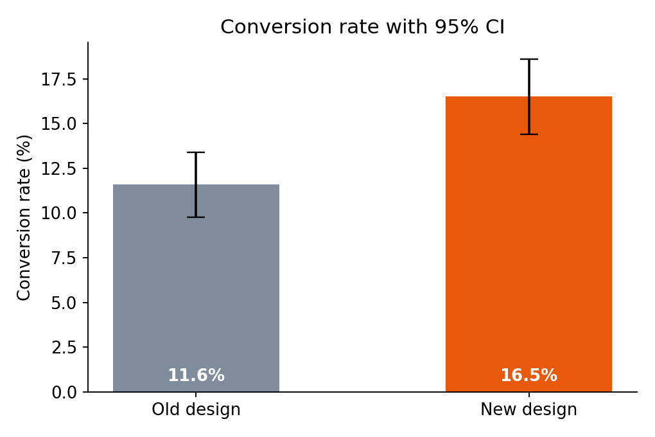
Figure 3: Conversion rate by design with 95% confidence intervals
How to read this: the bars show conversion and the black whiskers the 95% confidence interval. The intervals do not overlap much and the lift of 4.9 percentage points has a confidence interval entirely above zero, matching the significant test. Statistically the new design is clearly better; the checkout-time gain, by contrast, is small in effect size (d = 0.15) and mainly a supporting signal.
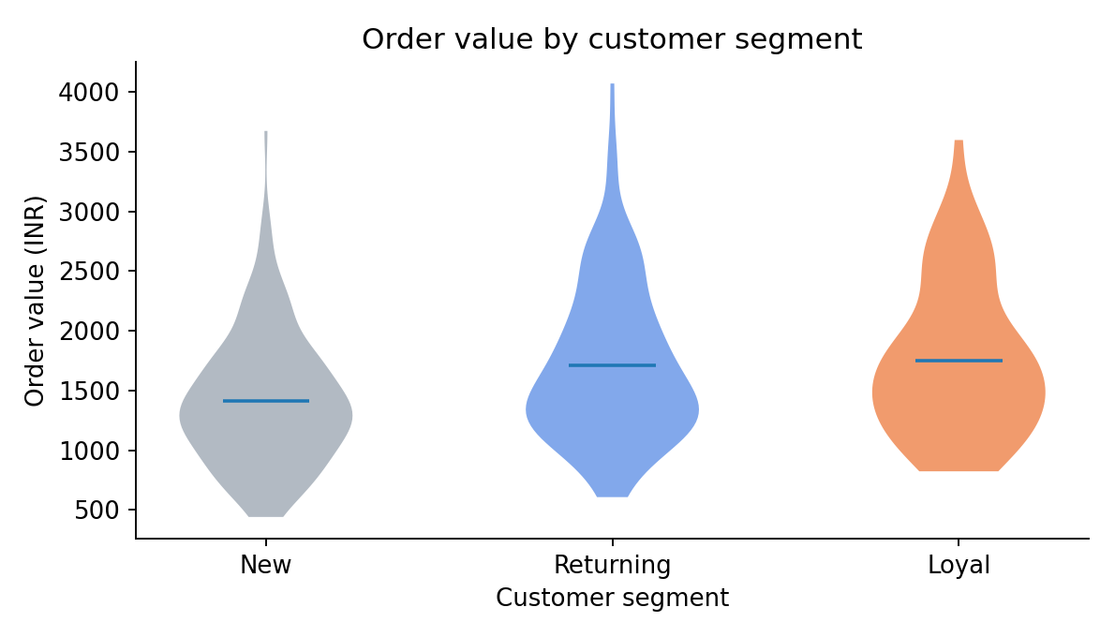
Figure 4: Order value by customer segment
How to read this: each "violin" shows the spread of order values; the wider the shape, the more orders at that value. New customers sit lower than Returning and Loyal customers, and Tukey comparisons confirm that New differs significantly from both (adjusted p < 0.001) while Returning and Loyal do not differ from each other (p = 0.89). The biggest step up in spending therefore happens at the second purchase.

3.3 Going further: from significance to business value
Hypothesis tests answer "is there an effect?" A decision maker also asks "does it hold for every group?", "does it change how much people spend?" and "what is it worth?" Three further analyses address these questions.
Is the lift consistent across devices? The lift is similar in size on every device (about 4 to 5 percentage points). It is individually significant on mobile only because the desktop and tablet groups are small and their intervals are wide.
Device | Sessions | Conversion Old | Conversion New | Lift (pp) | 95% CI (pp) | Relative lift
Mobile | 1309 | 8.7% | 13.7% | 5.0 | [1.5, 8.4] | +57%
Desktop | 859 | 15.6% | 20.6% | 5.0 | [-0.1, 10.2] | +32%
Tablet | 232 | 12.8% | 16.8% | 4.0 | [-5.2, 13.2] | +31%

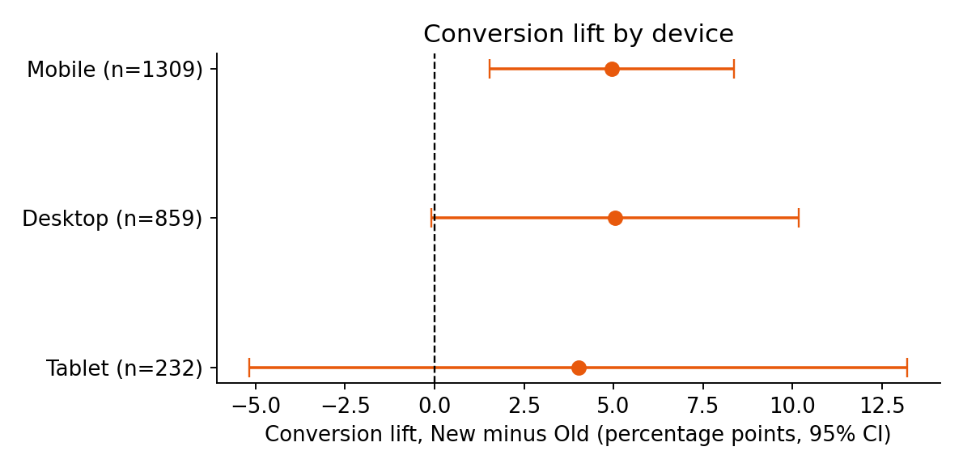
Figure 5: Conversion lift by device with 95% confidence intervals
How to read this: each dot is the estimated lift for a device and the line is its 95% confidence interval. If the line crosses the dashed zero line the lift is not individually significant. Lines for desktop and tablet cross zero only because they rest on fewer sessions, and all three dots sit in the same region, so there is no evidence that the redesign helps one device and harms another. Splitting into subgroups after the fact is a weak basis for conclusions, so this is treated as supporting evidence and a reason to plan a larger mobile test, not as proof of different effects.
Did the redesign change basket size? No. Average order value was ₹1,569 (Old) and ₹1,596 (New); a Welch t-test on log order value gave p = 0.64. The new checkout brings more buyers but not larger baskets. This means the revenue gain comes entirely through conversion.
What is the revenue gain, with uncertainty? Revenue per session (zero for non-buyers) was ₹182 for Old and ₹263 for New. A bootstrap with 5,000 resamples gives a difference of ₹82 per session with a 95% interval of ₹35 to ₹129; the difference was positive in 100.0% of resamples.
boot = np.empty(5000)
for i in range(5000):
boot[i] = rng.choice(new_r, len(new_r)).mean() - rng.choice(old_r, len(old_r)).mean()
ci = np.percentile(boot, [2.5, 97.5]) # 95% bootstrap interval for the revenue gain
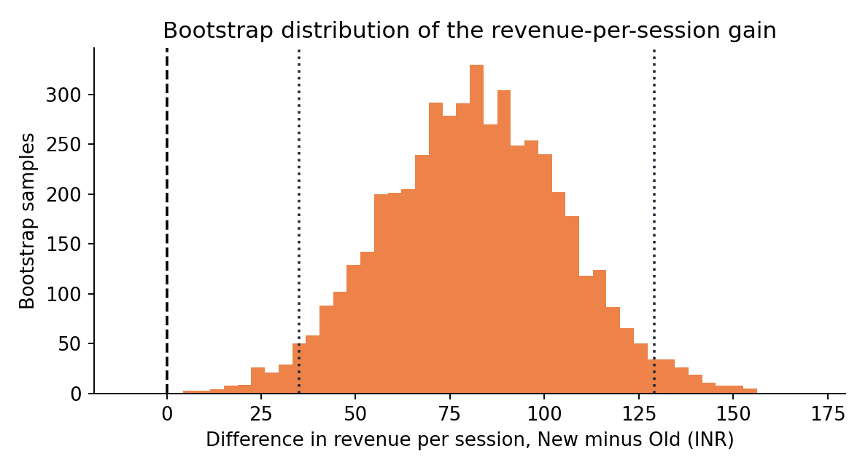
Figure 6: Bootstrap distribution of the revenue-per-session gain
How to read this: each bar counts how often a given revenue gain appeared across 5,000 resampled versions of the experiment. The whole distribution lies to the right of zero (dashed line), and the dotted lines mark the 95% interval. Bootstrapping is used here because revenue per session is highly skewed (most sessions earn nothing), where a normal-theory interval would be unreliable.

4. Case Study B: Predicting Tumour Malignancy

4.1 Data, preparation and model selection
The Breast Cancer Wisconsin (Diagnostic) dataset contains 569 patients (357 benign, 212 malignant) with 30 numeric features describing cell nuclei. There are no missing values or duplicates. Malignant was defined as the positive class because a missed cancer is the more serious error. Data were split 80/20 with stratification, and four algorithms were compared by 5-fold cross-validation on the training set before tuning.
Model | CV accuracy | CV recall | CV F1 | CV ROC AUC
Logistic Regression | 0.974 | 0.953 | 0.964 | 0.996
KNN | 0.965 | 0.918 | 0.951 | 0.987
Decision Tree | 0.923 | 0.894 | 0.896 | 0.917
Random Forest | 0.960 | 0.935 | 0.946 | 0.988

Annotation: values are cross-validated means on training data only. Logistic regression leads on every metric, and the unconstrained decision tree is weakest. Logistic regression was therefore selected before the test set was used.

4.2 Test-set performance
Model | Accuracy | Precision | Recall | F1 | ROC AUC | Missed cancers | False alarms
Logistic Regression | 0.965 | 0.975 | 0.929 | 0.951 | 0.996 | 3 | 1
KNN | 0.939 | 0.973 | 0.857 | 0.911 | 0.982 | 6 | 1
Decision Tree | 0.930 | 0.925 | 0.881 | 0.902 | 0.972 | 5 | 3
Random Forest | 0.965 | 1.000 | 0.905 | 0.950 | 0.994 | 4 | 0

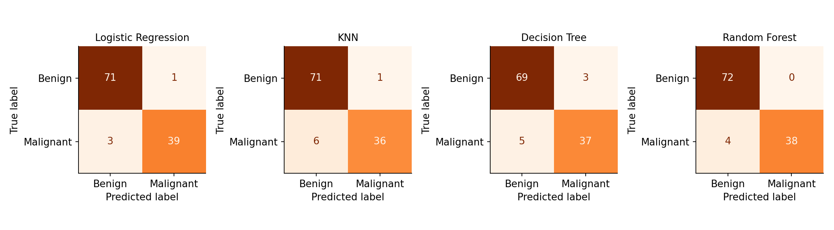
Figure 7: Confusion matrices of the four models on the test set
How to read this: in each 2×2 grid the rows are the true class and the columns the predicted class. The top-right cell counts false alarms (benign called malignant) and the bottom-left cell counts missed cancers (malignant called benign), the most serious error. Logistic regression has the fewest misses (3) and only 1 false alarm.
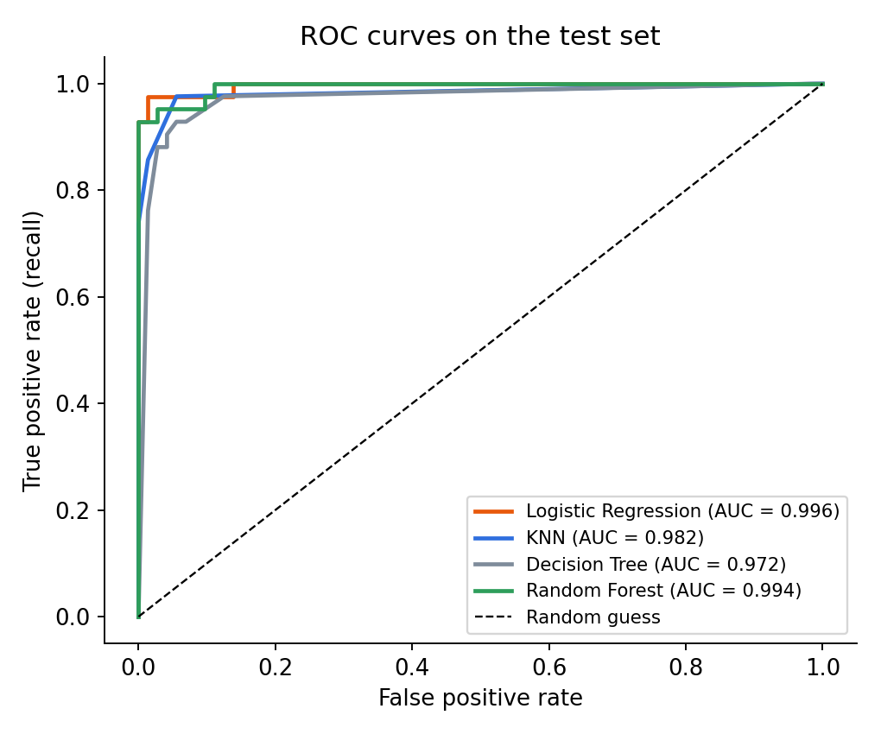
Figure 8: ROC curves on the test set
How to read this: each curve shows how many cancers are found (vertical axis) against how many benign cases are wrongly flagged (horizontal axis) as the threshold is varied; curves hugging the top-left corner are better. Logistic regression (AUC 0.996) and random forest (AUC 0.994) are nearly indistinguishable, while the decision tree is clearly lower.

4.3 Overfitting and generalisation
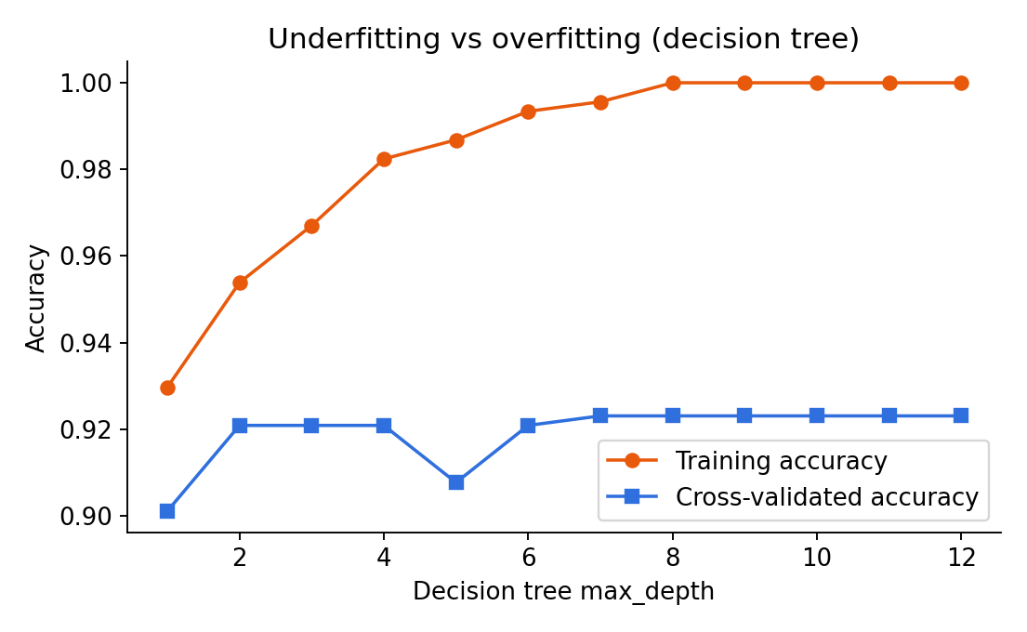
Figure 9: Training versus cross-validated accuracy for decision trees of increasing depth
How to read this: the orange line is accuracy on data the tree trained on and the blue line is accuracy on held-out folds. Shallow trees underfit (both lines low). Deep trees reach 100% training accuracy while validation accuracy stays flat at about 92%: the tree memorises noise. Logistic regression shows only a small gap (training 0.988 vs validation 0.974). Across 10 random splits its accuracy averaged 97.3% with a standard deviation of 1.5%, so a single test score is best read as a range of about 97% ± 1.5 points.
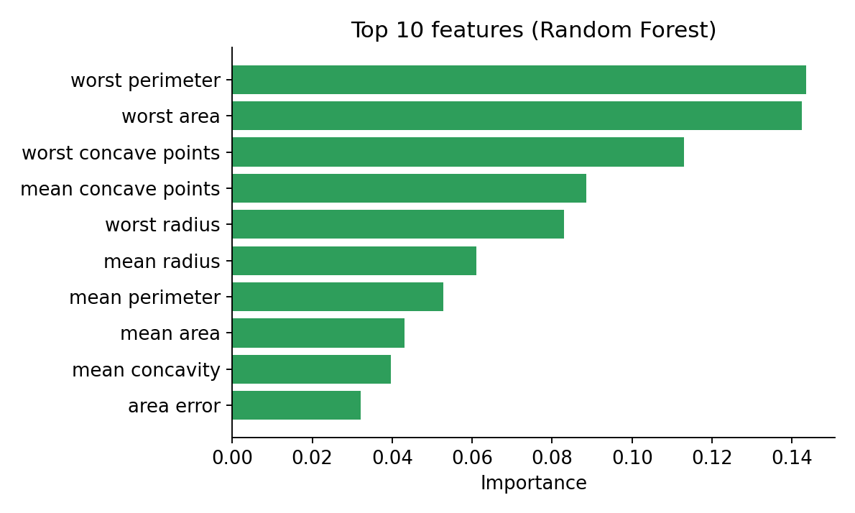
Figure 10: Top 10 features by random forest importance
How to read this: longer bars mean the forest relied more on that feature. The "worst" (largest) values of perimeter, area and concave points dominate, i.e. big, irregularly shaped nuclei signal malignancy, which fits medical intuition. Because many features are highly correlated, these rankings describe groups of related measurements, not exact individual effects.

4.4 Turning a model into a decision: cost-based threshold
A classifier outputs a probability; someone must decide at what probability to act. The default of 0.5 treats both errors as equally bad, which is not appropriate when a missed cancer is worse than a false alarm. In the earlier model study a lower threshold was explored on the test set only for illustration. Here the threshold is chosen properly: out-of-fold probabilities from cross-validation on the training set are used to compute the average cost at each threshold for several cost ratios, and the test set is used only once, afterwards, to confirm the result.
oof = cross_val_predict(model, X_tr, y_tr, cv=cv, method='predict_proba')[:, 1] # out-of-fold probabilities
def cost_curve(prob, truth, ratio):
# average cost per patient: false negatives cost `ratio`, false positives cost 1
...
t_best = thr[np.argmin(cost_curve(oof, y_tr.values, ratio))] # chosen WITHOUT using the test set
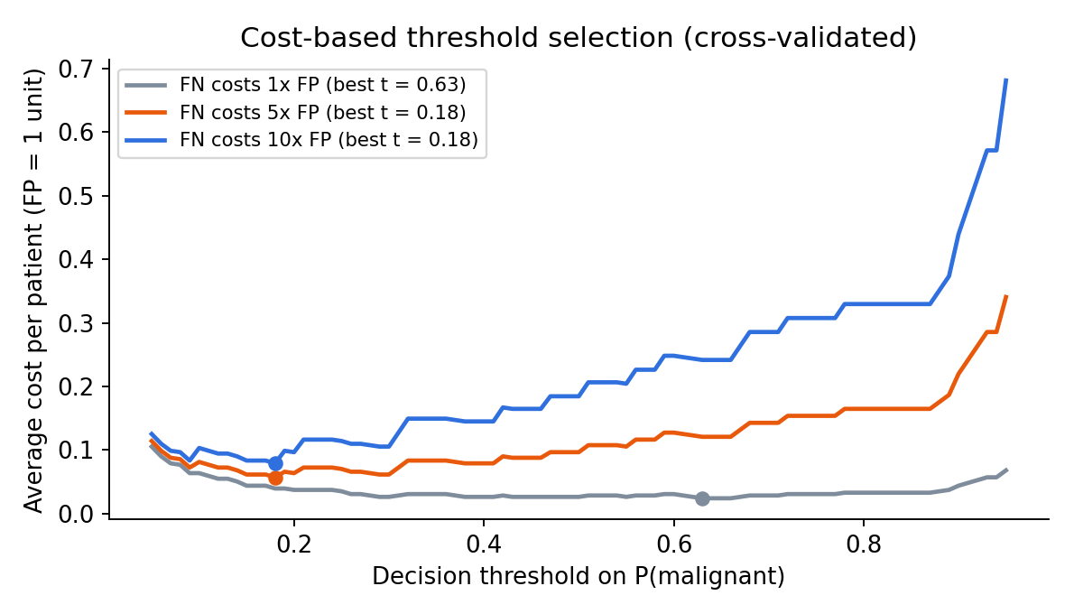
Figure 11: Cost-based threshold selection from cross-validated predictions
How to read this: each curve is the average cost per patient at a given threshold for a different assumption about how much worse a missed cancer is than a false alarm. The dot marks the lowest-cost threshold. When both errors cost the same, the best threshold is high (0.63); when a missed cancer is 5 or 10 times worse, the best threshold drops to 0.18, meaning the model should flag a case as malignant much earlier.
Decision rule | Threshold | Missed cancers | False alarms | Recall | Precision | Accuracy
Default | 0.50 | 3 | 1 | 92.9% | 97.5% | 96.5%
Cost ratio 5:1 and 10:1 | 0.18 | 1 | 4 | 97.6% | 91.1% | 95.6%

The cost-based rule found one more cancer than the default (3 missed down to 1) in exchange for 3 extra false alarms, with accuracy dropping only 0.9 percentage point. Note that with only 42 malignant cases in the test set, one patient changes recall by 2.4 points, so this is a direction, not a precise estimate.

5. Synthesis: Key Findings and Patterns
Looking across both case studies, several patterns appeared that are more general than either dataset. They are summarised below together with the evidence from each study.
Pattern | Evidence in Case A (A/B test) | Evidence in Case B (classifier)
Statistical significance is not practical importance | Checkout-time gain is highly significant (p < 0.001) but small (d = 0.15); conversion lift is both significant and large in business terms | Accuracy differences of 1 to 2 patients between top models are within noise
Uncertainty must travel with every number | Confidence and bootstrap intervals for time, conversion and revenue | 10-split stability check: 97.3% ± 1.5%
Subgroups are noisy | Device-level lifts have wide intervals because desktop and tablet samples are small | Only 42 malignant test cases, so recall moves in 2.4-point steps
Simple, well-validated methods are often enough | Welch t-test, chi-square and ANOVA answered the questions | Scaled logistic regression matched or beat random forest
Costs of errors should drive decisions | Revenue per session matters more than the p-value alone | Threshold chosen by cost ratio, not the default 0.5
Assumptions and leakage must be controlled | Normality, variance and expected-count checks; non-parametric cross-checks | Pipeline prevents leakage; test set untouched until the end

The common thread is that careful method matters more than sophisticated method. In both studies the biggest risks to a correct conclusion were not a lack of algorithms but over-reading small differences, ignoring uncertainty, and letting the test data influence choices.

6. Strategic Recommendations
Recommendations are grouped by stakeholder. For each one the evidence, the decision it supports, and how it improves outcomes are stated, so that a manager can see why it follows from the data.

6.1 For the e-commerce product and growth team
R1. Roll out the new checkout to all users and measure revenue per session. Evidence: conversion rose from 11.6% to 16.5% (p < 0.001), revenue per session rose by ₹82 with an interval entirely above zero, and basket size did not change. Decision supported: replace the old design. How it drives improvement: more of the existing traffic turns into paying customers without additional marketing spend. Track revenue per session as the main success measure because conversion alone could hide a drop in basket size.
R2. Keep a small holdback group after launch. Evidence: effects in simulated or short experiments can fade (novelty effect). Decision supported: confirm that the lift persists over several weeks. Keeping about 5% of traffic on the old design for a month gives a live control at low cost.
R3. Prioritise mobile with a dedicated follow-up test. Evidence: mobile is 55% of sessions but converts least (11.2% vs 18.2% on desktop). The redesign helps mobile (8.7% to 13.7%), yet it remains below desktop. Because mobile traffic is large, a further gain there is worth the most revenue. Planning note: to detect a lift of 2 percentage points from a 12% baseline with 80% power, about 4,438 sessions per group are needed, and about 2,036 for 3 points.
Lift to detect (from 12%) | 1 pp | 2 pp | 3 pp | 4 pp | 5 pp
Sessions needed per group (80% power) | 17,169 | 4,438 | 2,036 | 1,181 | 778

R4. Build a retention programme aimed at first-time buyers. Evidence: New customers spend about 17% less per order than Returning customers (mean ₹1,416 vs ₹1,714), and Returning and Loyal customers spend about the same. The largest step in value happens at the second purchase, so follow-up offers, post-purchase emails and loyalty incentives should aim at getting a first-time buyer to purchase again. Caution: segment comparison is observational, so test any programme with its own A/B experiment.

6.2 For clinical and hospital analytics stakeholders
R5. Use the model as decision support, never as the decision. Evidence: even the best model missed 3 of 42 cancers at the default threshold. A pathologist should review every case, with the model acting as a second reader that highlights cases deserving closer attention.
R6. Set the threshold from an explicitly agreed cost ratio. Evidence: moving from the default to a cost-based threshold of 0.18 reduced missed cancers from 3 to 1 on the test set at the price of 3 more false alarms. Clinicians, not data scientists, should decide how much worse a missed cancer is than a false alarm, and the threshold should follow from that decision and be reviewed regularly.
R7. Validate externally before any deployment. Evidence: all data come from one source and the test set has only 114 patients. Performance on images from other hospitals, scanners and staining protocols is unknown. Run a prospective or multi-site validation and monitor performance after launch.
R8. Calibrate and explain predictions. Evidence: predicted probabilities were used directly for thresholds. Calibrating them (Platt scaling or isotonic regression) and adding explanations such as SHAP would let clinicians trust and challenge individual predictions.

6.3 Prioritisation and roadmap
Rec. | Impact | Effort | Priority | Timeline
R1 Roll out new checkout | High | Low | 1 | 0–30 days
R2 Holdback group | Medium | Low | 2 | 0–30 days
R3 Mobile follow-up test | High | Medium | 3 | 30–90 days
R4 First-time buyer retention | Medium | Medium | 4 | 30–90 days
R5 Decision-support use only | High (safety) | Low | 1 | Immediate
R6 Cost-based threshold | High | Low | 2 | 0–30 days
R7 External validation | High | High | 3 | 90+ days
R8 Calibration and explainability | Medium | Medium | 4 | 30–90 days

7. Business Impact and Research Outcomes

7.1 E-commerce: projected impact
The table converts the measured revenue-per-session gain into an illustrative annual-scale figure. It assumes that the effect observed in the experiment persists, that traffic mix stays similar and that 100,000 sessions are served; real values should be recomputed with real traffic.
Scenario | Revenue gain per session | Gain per 100,000 sessions
Conservative (lower bound of 95% interval) | ₹35 | ₹3.5 million
Expected (point estimate) | ₹82 | ₹8.2 million
Optimistic (upper bound of 95% interval) | ₹129 | ₹12.9 million

Even the conservative scenario is positive, which is what makes the rollout recommendation robust: the decision does not depend on the optimistic estimate being right.

7.2 Clinical decision support: impact on errors
Scaling the test-set error counts to 1,000 patients with the same case mix (37% malignant) shows how the threshold choice changes outcomes:
Decision rule | Missed cancers per 1,000 | False alarms per 1,000
Default threshold 0.50 | 26.3 | 8.8
Cost-based threshold 0.18 | 8.8 | 35.1

Caution: the case mix here is far richer in cancers than real screening populations, where malignancy is much rarer. In a real population the same threshold would produce many more false alarms per true detection, so the threshold and workload must be re-evaluated on the intended population. These figures are for illustration only.

7.3 Research and learning outcomes
- A reusable workflow: a documented, seeded and leakage-safe template for hypothesis testing and for supervised classification that can be applied to new datasets.
- A decision-oriented reporting style: every result is paired with an effect size or interval and a plain-language "how to read this" explanation.
- A cost-aware evaluation approach: demonstrating that thresholds and success metrics should be tied to business or clinical consequences.
- Open questions for further research: Does the checkout effect vary by customer segment (an interaction)? Can a model predict which first-time buyers will return? Would gradient boosting or an SVM improve borderline tumour cases?

8. Limitations and Future Improvements
Limitation | Why it matters | Future improvement
E-commerce data are simulated | Built-in effects make results look cleaner than real data; no bots, repeat visitors or seasonality | Repeat the analysis on real experiment logs; account for users appearing in several sessions
Short, single experiment | Possible novelty effect; no long-term retention or returns data | Run longer, add a holdback group, measure repeat purchase and return rates
Subgroup samples are small | Device and segment estimates have wide intervals; observational, not causal | Pre-register subgroup tests and size them with power analysis (see sample-size table)
Multiple tests | More tests raise the chance of false positives | Bonferroni or false-discovery-rate correction (all main results stay significant after Bonferroni)
Small, single-source medical dataset | Estimates are noisy; unknown performance at other hospitals | External and prospective validation; larger multi-centre data
Collinear features | Coefficients and importances unstable | Regularisation, PCA or feature selection; SHAP for explanation
Threshold uses assumed cost ratios | True costs are a clinical judgement | Elicit cost ratios from clinicians; review them periodically
Single train/test split | Test set of 114 gives about ±1.5 point uncertainty | Nested or repeated cross-validation; report confidence intervals

9. Conclusion
This project followed a complete data science lifecycle on two different problems. The A/B test shows that the redesigned checkout increases conversion and revenue per session without changing basket size, with gains that remain positive even in a conservative estimate. The classifier shows that a simple, well-validated logistic regression can separate malignant from benign tumours with about 96.5% accuracy and 0.996 ROC AUC, and that the decision threshold, not only the algorithm, determines how many cancers are missed.
For stakeholders the main message is practical: adopt the new checkout and measure revenue, focus follow-up work on mobile and first-time buyers, treat the clinical model as decision support with a threshold set from an agreed cost ratio, and validate externally before any real use. For the analyst the main lesson is methodological: choose methods that fit the data, check assumptions, quantify uncertainty, keep test data clean, and always translate numbers into decisions and their consequences.

Appendix A: Glossary
Term | Plain-language meaning
Null / alternative hypothesis | The "no effect" claim being tested / the effect we hope to demonstrate
p-value | How surprising the data would be if there were truly no effect; small values (below 0.05) lead us to reject "no effect"
Confidence interval | A range of plausible values for the true effect; if it excludes zero the effect is statistically significant
Effect size (Cohen's d, Cramér's V, η²) | How large an effect is, independent of sample size
Conversion rate | Share of sessions that end in a purchase
Bootstrap | Re-sampling the data many times to estimate uncertainty without strong assumptions
Cross-validation | Training and validating a model on several different splits to estimate performance reliably
Data leakage | When information from test data accidentally influences training, making results look better than they are
Recall / precision | Share of real positives found / share of predicted positives that are correct
ROC AUC | How well a model ranks positives above negatives across all thresholds (1.0 is perfect, 0.5 is random)
Threshold | The probability above which a case is classified as positive

Appendix B: Project Files and Reproducibility
File | Purpose
analysis.py, ecommerce_ab_test_dataset.csv | Case study A: data generation, hypothesis tests and figures
ml_pipeline.py, breast_cancer_dataset.csv | Case study B: preprocessing, models, evaluation and figures
capstone.py | Capstone extensions: device lift, revenue bootstrap, cost-based threshold, workflow diagram
Week3, Week4 and Week5 .docx reports | Written documentation for each stage

Run each script with Python 3.9+ after installing pandas, numpy, scipy, scikit-learn and matplotlib. Random seed 42 is used throughout.

Appendix C: Capstone Analysis Code
Complete code for the extended analyses presented in Sections 3.3, 4.4 and 2. Code for the original tests and models is in the files listed in Appendix B.
import json
import numpy as np
import pandas as pd
import matplotlib
matplotlib.use("Agg")
import matplotlib.pyplot as plt
from matplotlib.patches import FancyBboxPatch
from scipy import stats
from sklearn.datasets import load_breast_cancer
from sklearn.model_selection import train_test_split, StratifiedKFold, cross_val_predict
from sklearn.pipeline import Pipeline
from sklearn.preprocessing import StandardScaler
from sklearn.linear_model import LogisticRegression
from sklearn.metrics import confusion_matrix

SEED = 42
rng = np.random.default_rng(SEED)
R = {}
plt.rcParams.update({"font.size": 11, "axes.spines.top": False, "axes.spines.right": False})
OR, GR, DK, BL, GN = "#E8590C", "#7F8C9B", "#1F2A37", "#2F6FDE", "#2E9E5B"

# =========================================================
# PART A. E-COMMERCE: deeper strategic analysis (Week 3 data)
# =========================================================
df = pd.read_csv("ecommerce_ab_test_dataset.csv")
df["revenue"] = df["order_value_inr"].fillna(0)

# A1. Lift by device
rows = []
for dev in ["Mobile", "Desktop", "Tablet"]:
o = df[(df.design == "Old") & (df.device == dev)].converted
n_ = df[(df.design == "New") & (df.device == dev)].converted
p0, p1 = o.mean(), n_.mean()
se = np.sqrt(p0 * (1 - p0) / len(o) + p1 * (1 - p1) / len(n_))
rows.append(dict(device=dev, n_old=len(o), n_new=len(n_), conv_old=p0, conv_new=p1, lift_pp=p1 - p0,
ci_low=p1 - p0 - 1.96 * se, ci_high=p1 - p0 + 1.96 * se))
R["device_lift"] = rows
fig, ax = plt.subplots(figsize=(7, 3.4))
for i, r in enumerate(rows):
ax.errorbar(r["lift_pp"] * 100, i, xerr=[[(r["lift_pp"] - r["ci_low"]) * 100], [(r["ci_high"] - r["lift_pp"]) * 100]],
fmt="o", color=OR, capsize=5, ms=7)
ax.axvline(0, color="k", ls="--", lw=1)
ax.set_yticks(range(3)); ax.set_yticklabels([f"{r['device']} (n={r['n_old']+r['n_new']})" for r in rows])
ax.invert_yaxis(); ax.set_xlabel("Conversion lift, New minus Old (percentage points, 95% CI)")
ax.set_title("Conversion lift by device")
plt.tight_layout(); plt.savefig("c1_device_lift.png", dpi=170); plt.close()

# A2. Does the redesign change basket size? (buyers only)
b = df.dropna(subset=["order_value_inr"])
bo, bn = np.log(b[b.design == "Old"].order_value_inr), np.log(b[b.design == "New"].order_value_inr)
tt = stats.ttest_ind(bn, bo, equal_var=False)
R["basket"] = dict(aov_old=float(b[b.design == "Old"].order_value_inr.mean()), aov_new=float(b[b.design == "New"].order_value_inr.mean()),
n_old=len(bo), n_new=len(bn), t=float(tt.statistic), p=float(tt.pvalue))

# A3. Revenue per session with bootstrap CI
old_r = df[df.design == "Old"].revenue.values
new_r = df[df.design == "New"].revenue.values
B = 5000
boot = np.empty(B)
for i in range(B):
boot[i] = rng.choice(new_r, len(new_r)).mean() - rng.choice(old_r, len(old_r)).mean()
R["revenue"] = dict(rps_old=float(old_r.mean()), rps_new=float(new_r.mean()), diff=float(new_r.mean() - old_r.mean()),
ci_low=float(np.percentile(boot, 2.5)), ci_high=float(np.percentile(boot, 97.5)),
prob_positive=float((boot > 0).mean()))
fig, ax = plt.subplots(figsize=(7, 3.8))
ax.hist(boot, bins=50, color=OR, alpha=0.75)
ax.axvline(0, color="k", ls="--"); ax.axvline(R["revenue"]["ci_low"], color=DK, ls=":"); ax.axvline(R["revenue"]["ci_high"], color=DK, ls=":")
ax.set_xlabel("Difference in revenue per session, New minus Old (INR)"); ax.set_ylabel("Bootstrap samples")
ax.set_title("Bootstrap distribution of the revenue-per-session gain")
plt.tight_layout(); plt.savefig("c2_revenue_boot.png", dpi=170); plt.close()

# A4. Illustrative projection per 100,000 sessions
R["projection"] = dict(sessions=100000, gain_mid=R["revenue"]["diff"] * 100000,
gain_low=R["revenue"]["ci_low"] * 100000, gain_high=R["revenue"]["ci_high"] * 100000)

# A5. Sample size needed for follow-up (per group, 80% power, alpha 0.05, two-sided) at baseline 12%
def n_needed(p1, p2, alpha=0.05, power=0.8):
za, zb = stats.norm.ppf(1 - alpha / 2), stats.norm.ppf(power)
pb = (p1 + p2) / 2
return int(np.ceil(((za * np.sqrt(2 * pb * (1 - pb)) + zb * np.sqrt(p1 * (1 - p1) + p2 * (1 - p2))) ** 2) / (p2 - p1) ** 2))
R["sample_size"] = {f"{l}pp": n_needed(0.12, 0.12 + l / 100) for l in [1, 2, 3, 4, 5]}

# =========================================================
# PART B. CLINICAL-STYLE MODEL: cost-based threshold chosen WITHOUT touching test set (Week 4 data)
# =========================================================
raw = load_breast_cancer(as_frame=True)
X, y = raw.data, (1 - raw.target)
X_tr, X_te, y_tr, y_te = train_test_split(X, y, test_size=0.20, stratify=y, random_state=SEED)
model = Pipeline([("scale", StandardScaler()), ("clf", LogisticRegression(C=1, max_iter=1000, random_state=SEED))])
cv = StratifiedKFold(5, shuffle=True, random_state=SEED)
oof = cross_val_predict(model, X_tr, y_tr, cv=cv, method="predict_proba")[:, 1] # out-of-fold probabilities

thr = np.round(np.arange(0.05, 0.96, 0.01), 2)
def cost_curve(prob, truth, ratio):
out = []
for t in thr:
p = (prob >= t).astype(int)
fn = ((p == 0) & (truth == 1)).sum(); fp = ((p == 1) & (truth == 0)).sum()
out.append((fn * ratio + fp) / len(truth))
return np.array(out)

ratios = [1, 5, 10]
chosen = {}
fig, ax = plt.subplots(figsize=(7, 4))
for r_, c_ in zip(ratios, [GR, OR, BL]):
cc = cost_curve(oof, y_tr.values, r_)
t_best = float(thr[np.argmin(cc)])
chosen[r_] = t_best
ax.plot(thr, cc, color=c_, lw=2, label=f"FN costs {r_}x FP (best t = {t_best:.2f})")
ax.scatter([t_best], [cc.min()], color=c_, zorder=5)
ax.set_xlabel("Decision threshold on P(malignant)"); ax.set_ylabel("Average cost per patient (FP = 1 unit)")
ax.set_title("Cost-based threshold selection (cross-validated)"); ax.legend(fontsize=9)
plt.tight_layout(); plt.savefig("c3_cost_threshold.png", dpi=170); plt.close()

model.fit(X_tr, y_tr)
prob_te = model.predict_proba(X_te)[:, 1]
res = []
for label, t in [("Default (0.50)", 0.5)] + [(f"Cost ratio {r_}:1", chosen[r_]) for r_ in [5, 10]]:
p = (prob_te >= t).astype(int)
tn, fp, fn, tp = confusion_matrix(y_te, p).ravel()
res.append(dict(rule=label, threshold=float(t), tp=int(tp), fp=int(fp), fn=int(fn), tn=int(tn),
recall=float(tp / (tp + fn)), precision=float(tp / (tp + fp)), accuracy=float((tp + tn) / len(y_te))))
R["thr_chosen"] = {str(k): v for k, v in chosen.items()}
R["thr_test"] = res

# =========================================================
# PART C. WORKFLOW DIAGRAM
# =========================================================
fig, ax = plt.subplots(figsize=(9.5, 2.6)); ax.axis("off"); ax.set_xlim(0, 10); ax.set_ylim(0, 2.6)
steps = ["1. Define\nproblem &\nhypothesis", "2. Collect &\nprepare data", "3. Explore &\nvisualise", "4. Test or\nmodel", "5. Validate &\ncheck errors", "6. Interpret &\nrecommend"]
for i, s in enumerate(steps):
x = 0.1 + i * 1.65
ax.add_patch(FancyBboxPatch((x, 0.6), 1.45, 1.4, boxstyle="round,pad=0.03", fc=OR if i in (0, 5) else "#FDE7D9", ec=DK, lw=1.2))
ax.text(x + 0.725, 1.3, s, ha="center", va="center", fontsize=9.5, color="white" if i in (0, 5) else DK, fontweight="bold")
if i < 5: ax.annotate("", xy=(x + 1.62, 1.3), xytext=(x + 1.47, 1.3), arrowprops=dict(arrowstyle="->", color=DK, lw=1.5))
ax.text(5, 0.2, "Applied in both case studies: A/B test (hypothesis testing) and tumour classifier (machine learning)", ha="center", fontsize=9.5, style="italic", color="#4B5563")
plt.tight_layout(); plt.savefig("c4_workflow.png", dpi=170); plt.close()

def clean(o):
if isinstance(o, dict): return {str(k): clean(v) for k, v in o.items()}
if isinstance(o, (list, tuple)): return [clean(v) for v in o]
if isinstance(o, (np.floating, float)): return float(o)
if isinstance(o, np.integer): return int(o)
return o
json.dump(clean(R), open("capstone_results.json", "w"), indent=1)
print(json.dumps(clean(R), indent=1))

Appendix D: References
- Virtanen, P. et al. (2020). SciPy 1.0: fundamental algorithms for scientific computing in Python. Nature Methods, 17, 261–272.
- Pedregosa, F. et al. (2011). Scikit-learn: Machine Learning in Python. Journal of Machine Learning Research, 12, 2825–2830.
- Wolberg, W. H., Street, W. N., & Mangasarian, O. L. Breast Cancer Wisconsin (Diagnostic) Data Set. UCI Machine Learning Repository.
- Kohavi, R., Tang, D., & Xu, Y. (2020). Trustworthy Online Controlled Experiments. Cambridge University Press.
- Efron, B., & Tibshirani, R. J. (1993). An Introduction to the Bootstrap. Chapman & Hall.
- Hastie, T., Tibshirani, R., & Friedman, J. (2009). The Elements of Statistical Learning (2nd ed.). Springer.
- Cohen, J. (1988). Statistical Power Analysis for the Behavioral Sciences (2nd ed.). Lawrence Erlbaum Associates.

